**Title:** Shielded metal arc welding (SMAW)

**HOME:**

**Home page purposes of SMAW**

Shielded Metal Arc Welding (SMAW), or stick welding, is crucial in various industries due to its versatility, adaptability to different environments, and cost-effectiveness. Its ability to weld a wide range of materials, produce high-strength welds, and facilitate emergency repairs makes it a reliable and accessible choice. SMAW's simplicity also makes it ideal for training novice welders, ensuring its continued importance in diverse industrial applications, from construction and infrastructure projects to emergency repairs and field welding.

**Background of the home page**

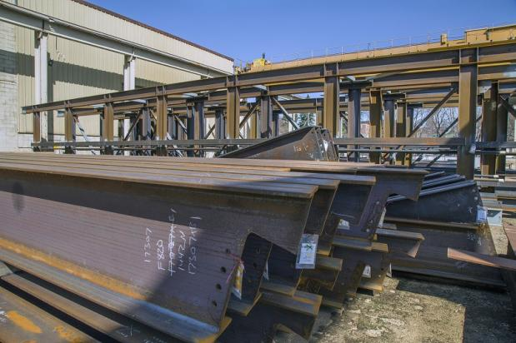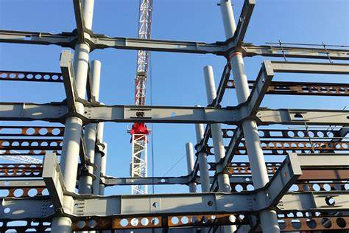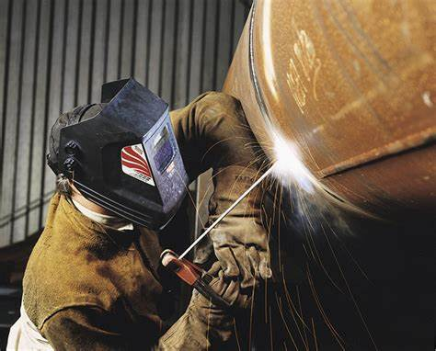

**ABOUT**:

**Welders:** Maladaga, Kenrick N.

Aranilla, Pierre Paolo C.

**Career Opportunities:**

Construction:

* Welders are employed in the construction industry to work on structural components, bridges, pipelines, and other infrastructure projects. Skilled welders are often needed for both residential and commercial construction projects.

Manufacturing and Fabrication:

* Welders play a crucial role in the manufacturing sector, working on the fabrication of metal products, machinery, and equipment. This includes industries such as automotive, aerospace, and consumer goods.

Infrastructure and Bridge Construction:

* Welders are needed for the construction and maintenance of bridges, highways, and other infrastructure projects. This may involve working with various welding techniques and materials.

**Environmental, Social and Purpose:**

Environmental Impact:

* Material Efficiency: Welders play a crucial role in ensuring efficient use of materials, minimizing waste during the fabrication and construction processes.
* Energy Consumption: The welding process itself involves energy consumption. Welders can contribute to environmental sustainability by adopting energy-efficient welding techniques and technologies.
* Environmental Compliance: Welders need to adhere to environmental regulations and standards to minimize the impact of their work on the environment.

Social Impact:

* Safety: Welders contribute to workplace safety by following strict safety protocols. Ensuring a safe working environment is essential to protect both the welder and their colleagues.
* Job Creation: The welding industry, especially in construction and manufacturing, contributes to job creation and economic development in local communities.
* Skill Development: Welders often engage in continuous learning and skill development. This not only enhances their own career prospects but also contributes to a skilled workforce in the community.

**Purpose and Ethical Considerations:**

* Quality Workmanship: Welders take pride in producing high-quality work. Ensuring the structural integrity of welded components is not only a professional responsibility but also a commitment to ethical practices.
* Project Contributions: Welders contribute to the completion of various projects, from constructing buildings to manufacturing products. Knowing that their work is a vital part of these projects can give a sense of purpose.

**Background of the ABOUT**

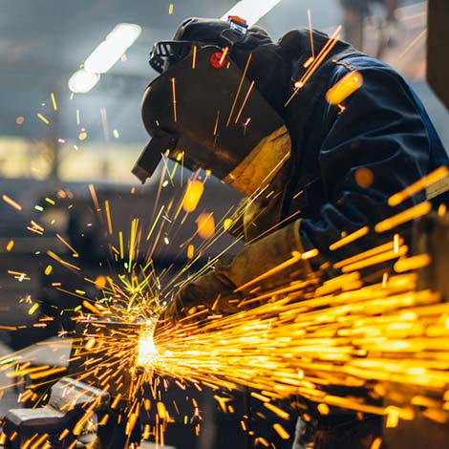

**WELDERS FORMAL ATTIRE**



**SERVICES:**

**Structural Welding:**

* + SMAW is frequently used in the construction industry for structural welding. Welders employ SMAW to join structural steel components, such as beams, columns, and girders, in the construction of buildings, bridges, and other infrastructure.

**Pipe Welding:**

* + SMAW is commonly used for welding pipes, both in construction and in industries such as oil and gas. Welders use this method to join pipes of different materials and thicknesses, creating strong and durable connections.

**Repair and Maintenance:**

* + Welders often use SMAW for repair and maintenance work. This includes fixing damaged metal structures, equipment, or machinery. SMAW is suitable for on-site repairs and is versatile enough to handle various repair
  + tasks.

**STRUCTURAL SERVICES**

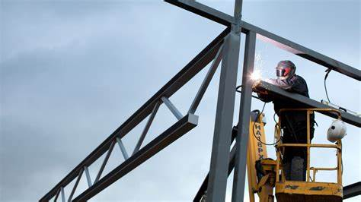

**Pipe welding**

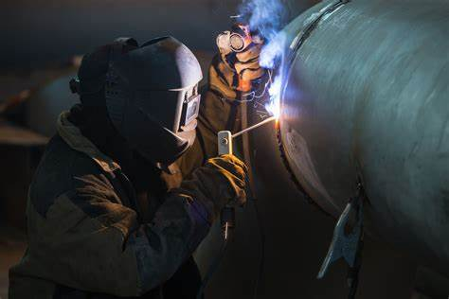

**Repair and Maintenance welding**

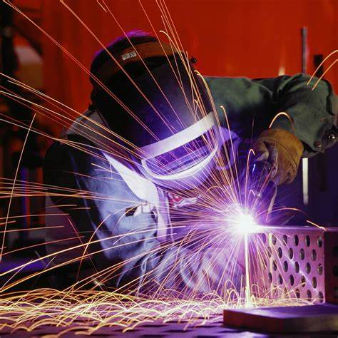

**CONTACT**

**Contact us the SMAW welders a skilled welder can create magic out of metal.**

**Name:**

**Email:**

**Phone:**

**Background of the contact**

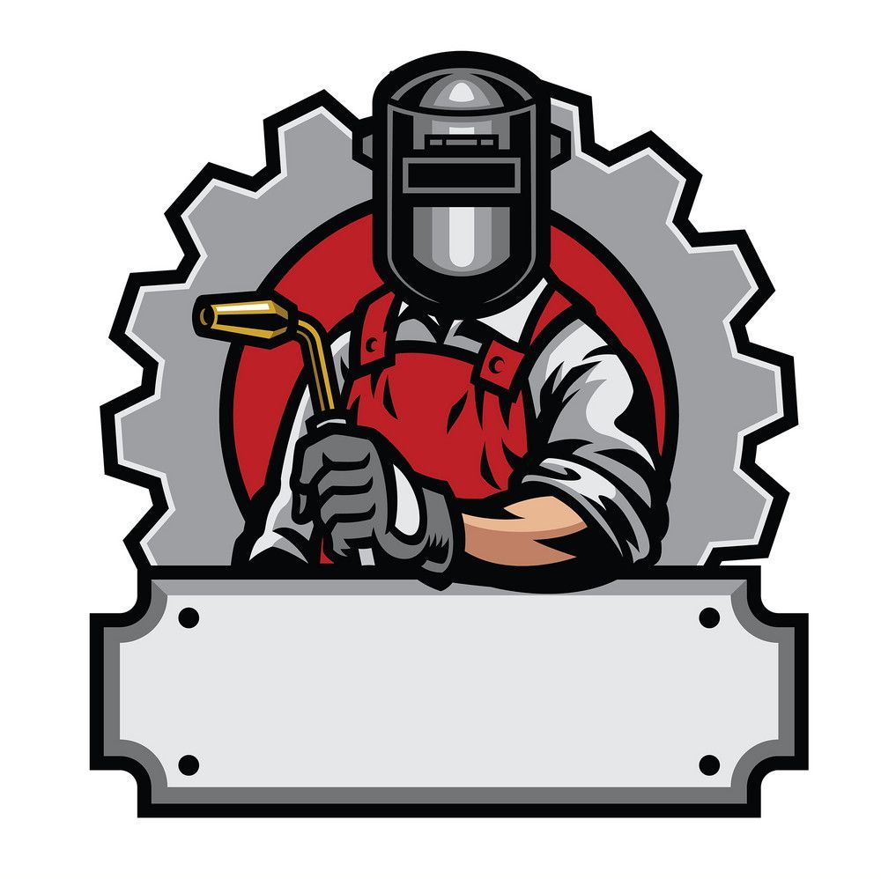

**FEEDBACK:**

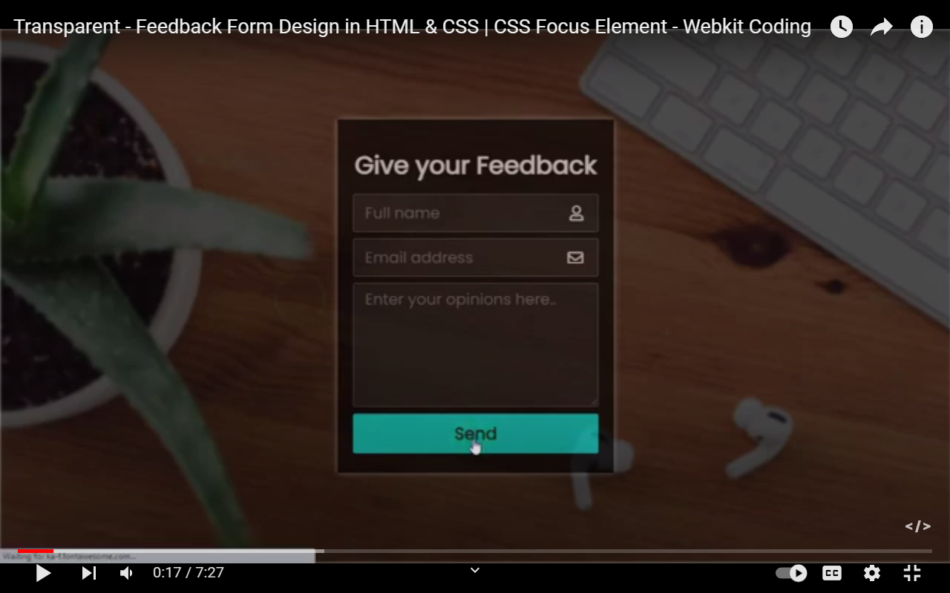

Background of feedback

